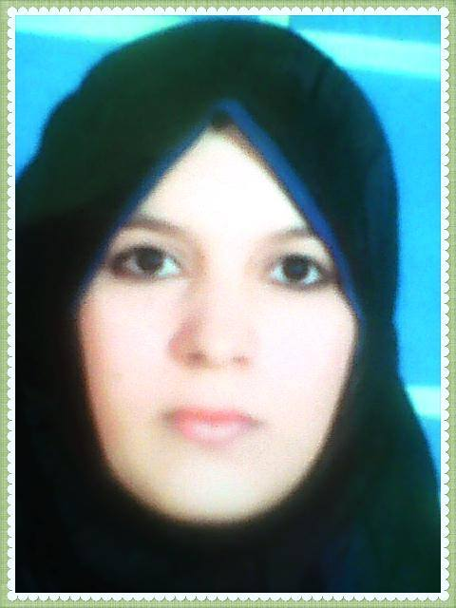
➢ Name / Doaa Ali Abdel Rahem Mfarag  ➢ Job/Teacher, Department of Social Planning, Faculty of Social Work, Assiut University.  ➢Nationality: Egyptian.  ➢City of Birth: Assuit – sahel selem  ➢Date of Birth: 1/3/1992.  ➢Religion: Muslim | Personal Information
➢Bachelor’s degree in social work in 2014 from the Faculty of Social Work, Assuit University, Very good with honors  ➢Master’s in social work "Specialization in Social Planning" in 2017 entitled " Requirements for the application of electronic management in the organizational structure of social welfare institutions) with excellent grade.  ➢PHD of Philosophy in Social Work "Social Planning Specialization" in 2022 entitled "The planning for development of partnership between government and civil institutions for achievement economic empowerment  To rural people . | Education
➢ Instructor, Department of Social Planning, Faculty of Social Work, Assiut University, 2022  ➢Assistant Lecturer, Department of Social Planning, Faculty of Social Work, Assiut University in 2017.  ➢Teaching Assistant, Department of Social Planning, Faculty of Social Work, Assiut University, 2014. | Job grades
I have received a number of training courses  ➢Capacity development courses for faculty members .  ➢Training course on professional behavior .  ➢Effective presentation training course .  ➢Training course on the credit hour system .  ➢A training course on communication skills in different types of education ..  ➢A training course on statistical analysis in scientific research ..  ➢A training course on publishing research in international journals.  ➢training course on the ethics of scientific research..  ➢training course on crisis management .  ➢training course on analytical and creative thinking in teaching ..  ➢A course on organizing international conferences .  ➢ Quality standards in the teaching process .  ➢A training course on the technical aspects of designing. and conducting scientific research ..  ➢A course on automatic correction .  ➢course on advanced automatic correction .  ➢A course on preparing a specification table .  A course on content analysis .. ➢Elective Course  ➢Teacher preparation course .  ➢A number of scientific conferences have been attended.  Conference on strategic planning .. ➢.  ➢Conference on the management system of educational institutions..  ➢Conference on the budget in private institutions.  ➢Conference on quality and sustainable development.. | Training
➢Research entitled "Electronic management as an entrance to improve social welfare services Research ".  published in the Scientific Journal of Social Work, Faculty of Social Work, Assiut University, 2017.  ➢Research entitled "Economic Empowerment for the Rural Poor .".  (Research published in the Scientific Journal of Social Work, Faculty of Social Work, Assiut University, Sixteenth Issue, Volume Two, 2021..  ➢ A research entitled "Partnership between government and private institutions and achieving economic empowerment for the rural poor .  (Research published in the Scientific Journal of Social Work, Faculty of Social Work, Assiut University, Sixteenth Issue, Volume Two, 2021. | Scientific research

